Use Case Document

Q5
Norris Cotton Cancer Center/Dartmouth College

DOCUMENT REVISION HISTORY
Version Number | Date | Description
1.0 | 06/15/2005 | - Draft constructed by David Jewell
1.1 | 07/05/2005 | - OHSU Revised
1.2 |  | - Review of document by Paul Courtney based on comments by Juli Klemm (9/25/2005)

Background/Summary
1st Draft
2nd Draft
Redefined type of user from Bioinformatics to Biostatistician and clarified that the application will be able to work both stand alone and through spectra checkout.

Table of Content
Requirements Specification 1
Q5 1
Background/Summary 1
1 Introduction 4
1.1 Overview 4
1.2 Related Documents 6
2 Actors and Goals 6
2.1 Bioinformatic specialist and Researcher 6
2.2 Mass spectroscopist 6
3 Use Cases 7
3.1 Current Q5 use case (legacy level) sample classification 7
3.1.1 Use Case Model 7
3.1.2 Brief Description 7
3.1.3 Primary Actor 8
3.1.4 Preconditions 8
3.1.5 Basic Flow of Events 8
3.1.6 Special Requirements 8
3.2 Q5 use case sample classification 9
3.2.1 Use Case Model 9
3.2.2 Brief Description 9
3.2.3 Primary Actor 9
3.2.4 Secondary Actors 9
3.2.5 Preconditions 10
3.2.5.1 Only for spectra DB recall scenario. LIMS system must be able to accept authentication of users for Q5 based check out and annotate spectra. 10
3.2.6 Basic Flow of Events 10
3.2.7 Postconditions 10
3.3 Q5 use case spectra quality control 10
3.3.1 Use Case Model 10
3.3.2 Brief Description 10
3.3.3 Secondary Actors 11
3.3.4 Preconditions 11
3.3.4.1 LIMS system must be able to accept authentication of users for Q5 based annotation of spectra 11
3.3.4.2 LIMS system must be able to accept authentication of users for Q5 based annotation of spectra 11
3.3.5 Basic Flow of Events 11
3.3.5.1 No Special Requirements 11
4 Overall Requirements 11
4.1 Requirements Prioritization 11
5 Data Definitions 12
6 Sign Off 13
6.1 Approval 13

Introduction

Overview
The Q5 application is a probabilistic classification algorithm that employs principal components dimension-reduction and linear discriminant analysis.
Q5 has shown utility in disease classification of expression-dependent proteomic data from mass spectrometry of human serum. Q5’s ability to classify complex fragment mixtures was evaluated by testing its ability to discriminate the mass spectra of healthy vs. disease human serum samples. The two disease states examined in testing were ovarian and prostate cancer. Existing screening methods for both cancers carry a low positive predictive value (PPV). When detected early, the 5-year survival rate increases for both cancers.
Q5 outputs a classifier (discriminant) capable of classifying new mass spectra into one of the classes. The new spectra (called test spectra) that have not been seen by the algorithm and their classifications are unknown to the algorithm; the goal of the Mass Spectra Classification Algorithm (MSCA) is to determine the correct classification based on the classifier constructed from the training set. Classification verification is the testing process by which the discriminant is evaluated for its ability to correctly diagnose test samples. MSCAs can be characterized by the type of MS data processed, type of algorithm employed, and method of classification verification used.
Completeness of mass spectrum. Analysis may be performed on either complete or partial mass spectra. Complete mass spectra consist of the relative intensities of all m/z values acquired during MS data collection. This includes the relative intensities observed for all m/z values from 0 up to the upper limit of detection. An MSCA that processes complete mass spectra works with the entire recorded spectra: no values are “manually” excluded through preprocessing. When portions of a spectrum are excluded from consideration, we say a partial spectrum is generated.

7

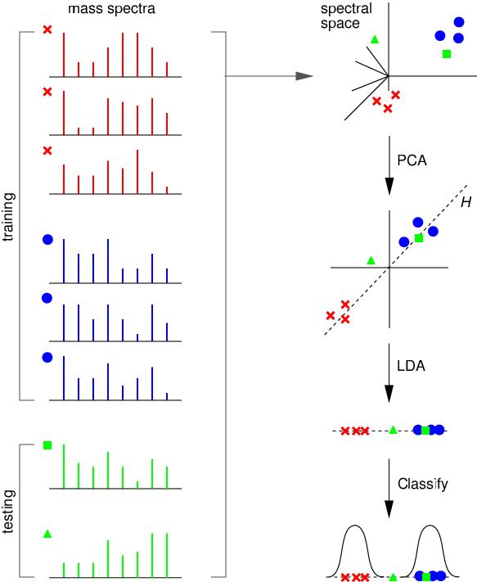

Figure 1: Major Steps of the Q5 Algorithm. The steps involved in building a two-class classifier are illustrated using simplified artificial spectra. On the left are training (x, •) and testing (, ∆) spectra. Shown on the right, from top to bottom, are (1) the spectral space representation of each spectrum; (2) PCA: the result of dimensionality reduction (for simplicity we show the projection onto just the top two principle components); (3) LDA: the projection of each spectrum onto the discriminant surface H; and (4) the probabilistic classification. In this example the testing spectrum denoted by is classified as belonging to the class denoted by o, while the spectrum denoted by ∆ is unclassified.

Heuristic vs. Exact Classification Algorithms. Heuristic classification algorithms include approaches such as genetic algorithms, neural networks, and simulated annealing. These algorithms generally require multiple iterations to converge to a classifier; furthermore, the solution found by heuristic algorithms is not guaranteed to be optimal. In addition, many heuristic approaches are non-deterministic. Even when run on the same training set, the same non-deterministic algorithm often converges to a different discriminant. In contrast, MSCAs that utilize closed-form exact solutions (CFES) compute an exact solution using closed-form equations. CFES algorithms are computationally efficient; they are non-iterative and deterministic (i.e., always compute the same solution). Linear Discriminant Analysis (LDA), and thus Q5, are CFES algorithms.

Related Documents
The Q5 distribution contains a set of Matlab (Mathworks Inc, Natick, MA) functions. Q5 is written entirely in Matlab.
Reference: Ryan H. Lilien, Hany Farid, and Bruce R. Donald. "Probabilistic Disease Classification of Expression-Dependent Proteomic Data from Mass Spectrometry of Human Serum." Journal of Computational Biology, 10(6) 2003, pp. 925-946.

Actors and Goals

Bioinformatic specialist and Researcher
Bioinformatic specialist is the primary actor and default user. This user datamines spectra and combinations of spectra. The user is a basic system actor that can submit spectra to Q5 for analysis as well as check out or download data from a MS compatible LIMS databases.

Mass spectroscopist
Mass spectroscopist is a primary actor. This user tests and assesses spectra quality. The user is a basic system actor that can submit spectra to Q5 for analysis as well as check or download data from a MS compatible LIMS database.

Use Cases

Current Q5 use case (legacy level) sample classification

Use Case Model
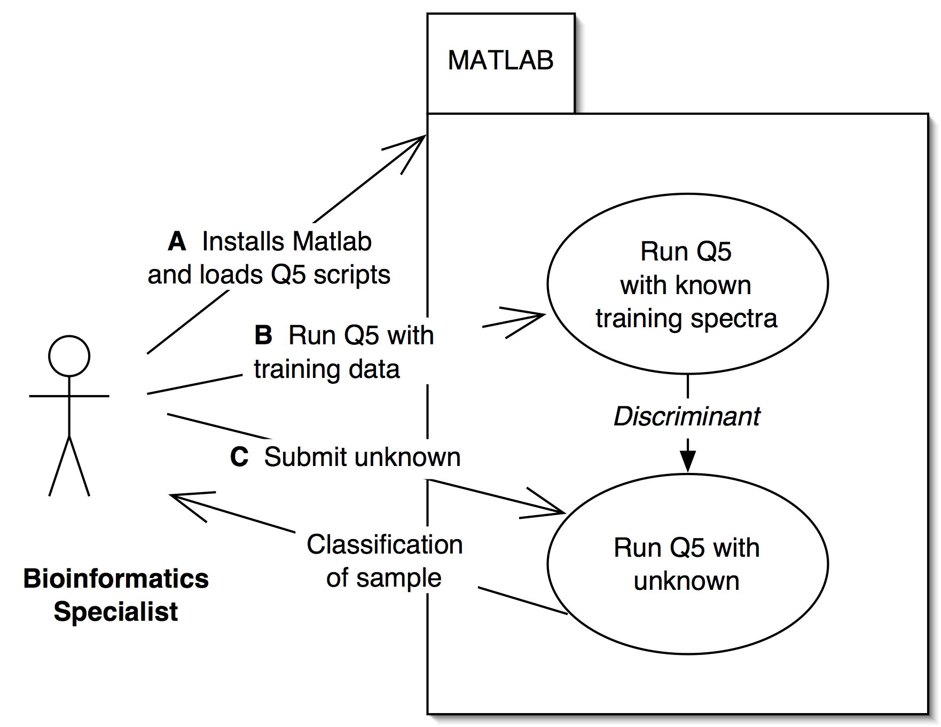

Brief Description
Currently
- Biostatistician specialist obtains and installs Matlab from Mathworks Inc. on personal computer. User downloads current Q5 scripts written in Matlab language from web site http://www.cs.dartmouth.edu/~donaldlab/Software/Q5_Dist.tar.gz, installs them within Matlab as instructed in the ReadMe.txt file also included in the distribution.
- User manually loads data set for training of Q5
- User loads unclassified spectra for Q5 classification.

Primary Actor
Biostatistician specialist

Preconditions
Matlab Installed

Basic Flow of Events

User submits training data sets for discriminant construction
User submits unknown spectra for classification

Special Requirements

In order for successful classification to occur the quality of both the training set as well as the unknown should be at a level that is not yet quantifiable.

Issues in usability and architecture:
- Format conversion
- Local license and install of Matlab that does not resemble a federated model of application usage.
- Accounting of user workflow and usage of data treatments does not occur within the application.
- Standardized output for clear understanding by user for significance of evaluation has not been engineered

Q5 use case sample classification

Use Case Model
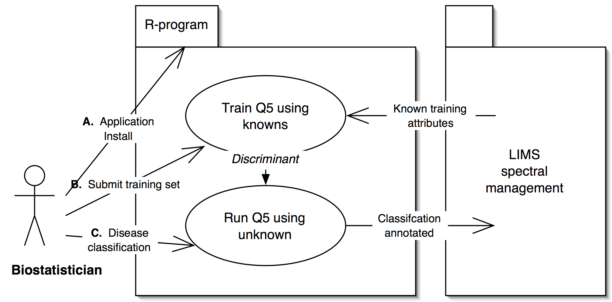

Brief Description
    - Biostatistician installs R program and Q5 plugin.
    - Generates discriminant with submitted (or spectra DB recalled) training data set of spectra.
    - Submits unknown spectra for classification and generates evaluation for annotation of spectra.

Primary Actor
Biostatistician specialist is the Primary Actor of this case.

Secondary Actors

Automated evaluation of spectra already in database set up by primary actor

Preconditions

Only for spectra DB recall scenario. LIMS system must be able to accept authentication of users for Q5 based check out and annotate spectra.

Basic Flow of Events

User submits training data sets for discriminant construction
User submits unknown spectra for classification

Postconditions
Classification is annotated to spectra

Q5 use case spectra quality control

Use Case Model
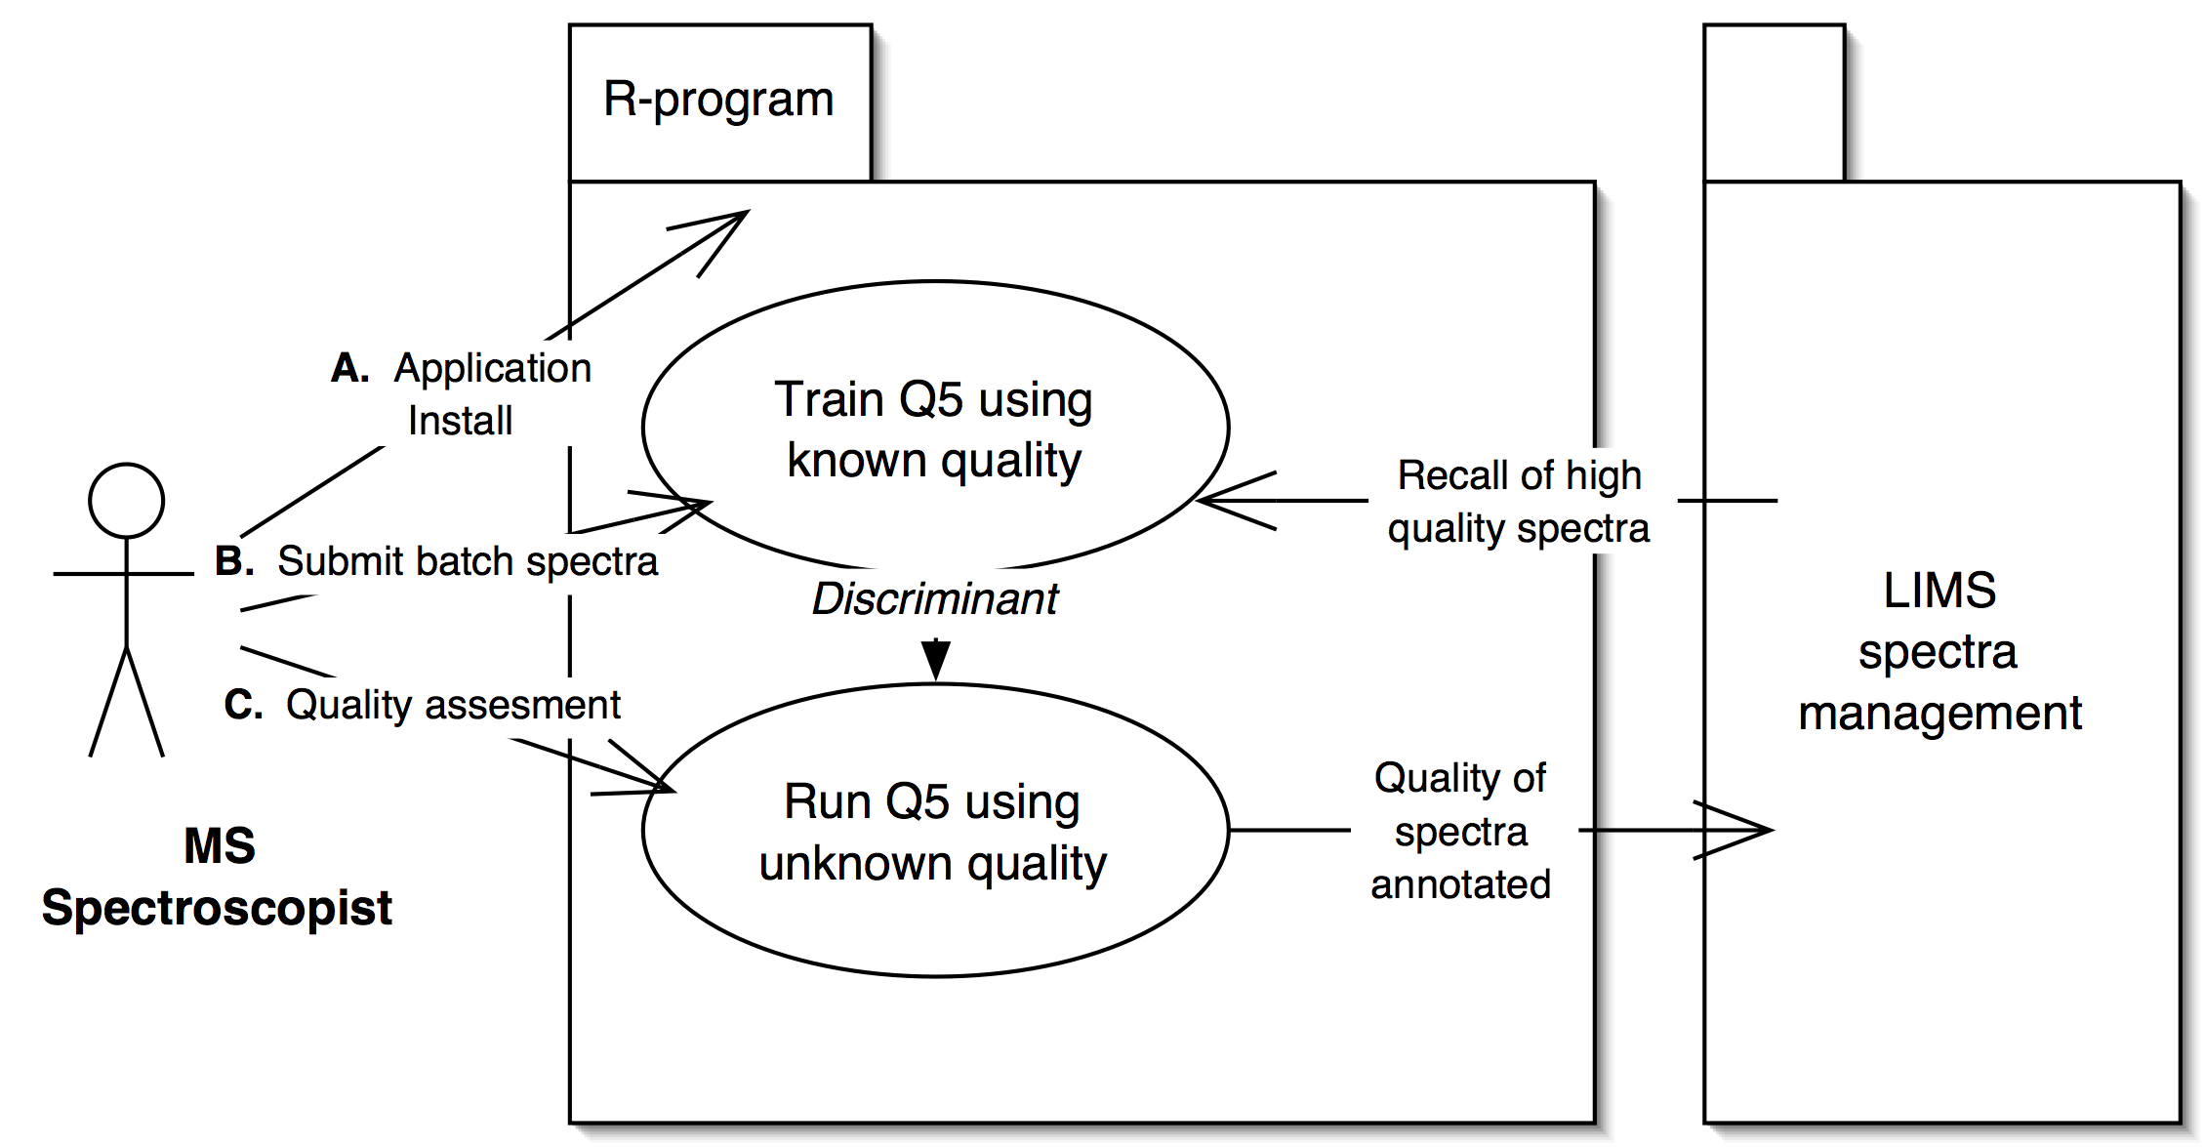

Brief Description

    - Primary actor installs R and Q5 plugin.
    - Primary actor submits and or recalls batch spectra for training and generating the discriminant.
    - Primary actor classifies unknown spectra for quality.

Secondary Actors

Automated evaluation of spectra quality relative to already in database set up by primary actor.

Preconditions

LIMS system must be able to accept authentication of users for Q5 based annotation of spectra

LIMS system must be able to accept authentication of users for Q5 based annotation of spectra

Basic Flow of Events
User (Mass spectroscopist):
Selects or submits data set as standard for comparison
Submits unknown spectra for quality assignment
Makes determination based on Q5 categorization

No Special Requirements

Overall Requirements

Requirements Prioritization

Priority | Use Case Name | Supp Requirement Ref #
1 | 3.2 sample classification
2 | 3.3 spectra quality control

Data Definitions
<Under construction>

Sign Off

Approval

Workspace General Contractor Rep Print Name Date
Architecture Workspace Rep Print Name Date
VCDE Workspace Rep Print Name Date
Workspace Working Group Rep Print Name Date
NCICB Rep Print Name Date

